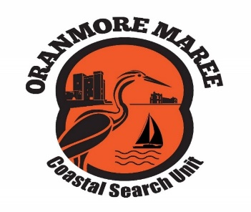
Oranmore Maree Coastal Search Unit CLG
Annual General Meeting – Nomination Form

Position | Person Nominated | Nominated by: | Confirm that the person nominated is willing to accept the role:
Director/Trustee
Chairperson
Secretary
Treasurer
PRO/Media
Search Co-Ordinator/
Location Officer
Catering
Pastoral Care
Training Officer/Agencies Liaison
Quartermaster
Leaders Representative
Boat Officer
Fundraising Officer
Drone Officer
Compliance/Governance

Signed by: _____________________________ Date: _______/________/____________
All persons nominated will be contacted in advance of the AGM to confirm their nomination and the time commitment for the Role.
The Oranmore Maree Coastal Search Unit Company Limited by Guarantee (OMCSU) was set up with the following main objectives:
- To carry out the business of search, rescue and recovery on both land and water.
- To provide leaders to co-ordinate and lead searches and to assist the statutory and other voluntary organisations in the rescue or recovery of casualties.
- To provide pastoral care to the family and friends of casualties
- to provide a base for the co-ordination of searches and the provision of refreshment and support for the searchers.
- Those who will benefit from our unit are the families, friends and communities of casualties and the other statutory and voluntary organisations who require our assistance.

