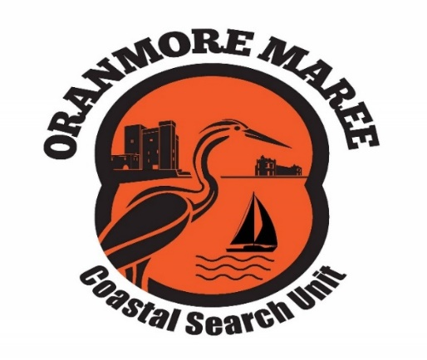

**Oranmore Maree Coastal Search Unit CLG**

**Annual General Meeting**

**Date: 4th December 2022**

**Time: 18:00**

**Venue: Oranmore Lodge**

**Agenda**

1. Chairperson’s welcome
2. Apologies
3. Minutes of previous minutes
4. Matters arising
5. Presentation of Reports
6. Treasurer’s Report
7. Financial Statements year-ended 31 December 2021
8. Election of Company Directors
9. Election of Committee
10. AOB

By Order Company Secretary Sean Greene

**The Oranmore Maree Coastal Search Unit Company Limited by Guarantee (OMCSU) was set up with the following main objectives:**

* To carry out the business of search, rescue and recovery on both land and water.
* To provide leaders to co-ordinate and lead searches and to assist the statutory and other voluntary organisations in the rescue or recovery of casualties.
* To provide pastoral care to the family and friends of casualties
* to provide a base for the co-ordination of searches and the provision of refreshment and support for the searchers.
* Those who will benefit from our unit are the families, friends and communities of casualties and the other statutory and voluntary organisations who require our assistance.